ATAR Chemistry – Unit 1 & 2

Task 13 : Research Assignment – Quiz SOLUTIONS

Chromatography

**Part 1: Multiple-choice (answer by neatly writing your response in the column to the right) (4 marks)**

|  |  |
| --- | --- |
| 1. In Thin Layer Chromatography what does the symbol “RF” stand for? |  |
| * 1. Chromatography factor | **B** |
| * 1. Retardation factor |
| * 1. Retardation frequency |
| * 1. Chromatography frequency |
|  |  |
| 1. High-performance Liquid chromatography is used to separate which of the following? |  |
| * 1. Small organic molecules | **C** |
| * 1. Small covalent molecules |
| * 1. Large organic molecules |
| * 1. Large ionic molecules |
|  |  |
| 1. In High-performance Liquid chromatography the mobile phase is… |  |
| * 1. Plasma | **C** |
| * 1. Gas |
| * 1. Liquid |
| * 1. Solid |
|  |  |
| 1. What is the stationary phase in Gas chromatography? |  |
| * 1. A long, thin column. | **A** |
| * 1. Absorbent paper |
| * 1. A short column |
| * 1. Fine powder on glass or plastic |
|  |  |
|  |  |
|  |  |
|  |  |

**Part 2: Short Answer Questions:**

1. In thin film chromatography components of the mixture being analysed are separated. **( 2 marks)**

What 2 processes allow the components to be separated?

* + 1. Difference in solubility
    2. Difference in adsorption to the adsorbent

1. Draw a sketch of a Thin film chromatography set-up and label it. On your diagram

include the terms solvent, stationary phase, mobile phase, sample, analyte, absorbent material (adsorbent)

*(hint more than one word may be used for each part.)* (**4 marks – 1 for correct diagram, ½ mark per label)**

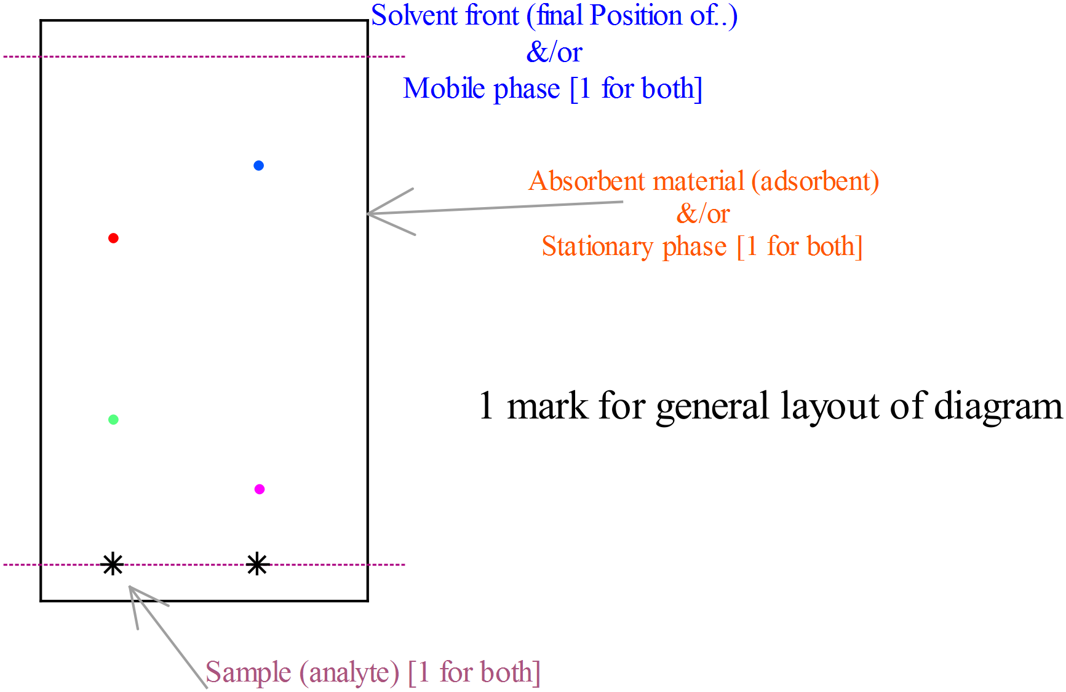

1. Rf is characteristic of the material being analysed and can have a value between 0 and 1. **(2 marks)**

What does it mean when:

Rf = 1: No adsorption

Rf = 0: No migration

4

a i X travelled fastest* because it had the smallest retention time*.

ii Y is present in the highest concentration* because it has the largest peak area*.

(4 marks)

b i A calibration curve is necessary to relate the concentration of a substance to the area of the peak*.

ii A solution of X of precise concentration is made up (1)*. This solution is used to prepare a set of standard diluted solutions of various concentrations* (1). Place these diluted solutions through the HPLC under the same conditions as the analysis of the pond water (1)*. Plot the area under the peak against the concentration of each standard* (1). (4 marks)

c X and Z peaks at 8 minutes and 15 minutes respectively*.

X peak area is 10* and Z peak area is 20*.

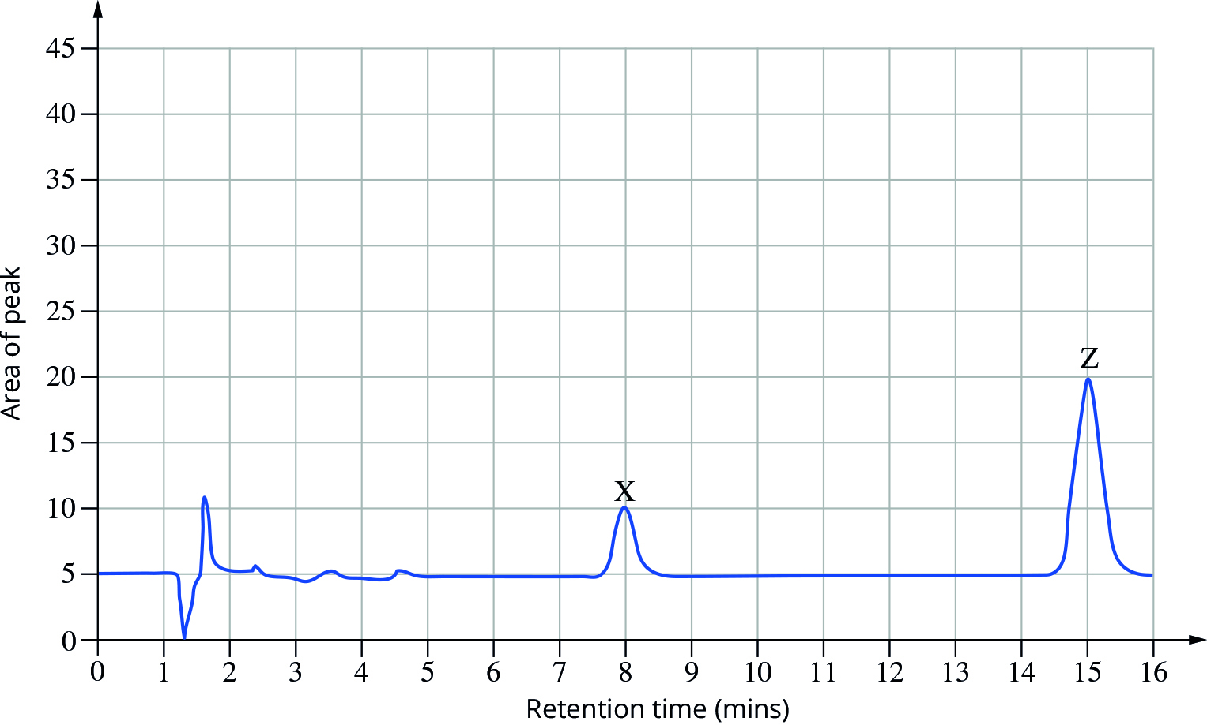

(3 marks)

1. Describe an application of gas Chromatography ( 2marks )

Tests small molecular weight heat stable organic compounds such as ethanol (1)

Applications, drug screening, oils in creams, toxicology, air borne pollutants, metabolic diseases (1)

|  |  |  |  |
| --- | --- | --- | --- |
| **Gas Chromatography** | Long thin column | Inert gas, eg N2, CO2 | Small heat stable organic compounds such as ethanol |

Section B: Water Notes ____ /6

**Part 1: Multiple-choice** (answer by neatly writing your response in the column to the right) [4 marks]

|  |  |
| --- | --- |
| 1. Why is chlorine added to drinking water? |  |
| * 1. To remove heavy metals | **C** |
| * 1. To remove oxygen |
| * 1. To kill various pathogens (bacteria, viruses etc) |
| * 1. To make it slightly blue in colour. |
|  |  |
| 1. Which of the following elements is attributed to causing soil acidification? |  |
| * 1. Nitrogen | **A** |
| * 1. Carbon |
| * 1. Chlorine |
| * 1. Fluorine |
|  |  |

**Part 2: Short Answer Questions:**

1. Describe, using chemical equations as appropriate, how increased levels of carbon dioxide in the atmosphere can cause acidification of oceans. [3]

Increased concentrations of CO2 in the atmosphere increase concentrations of CO2 in water. [1]

When CO2 dissolves in water it creates carbonic acid (according to the reaction) [1]

The presence of carbonic acid decreases the pH

1. For any source of drinking water in this state: [Total 5]
   1. Describe how the water is collected. [1]

Must identify source with appropriate description, could include reservoirs, desalination, bores

* 1. Describe two steps take to make it potable/ safe to drink. [2]

Two steps should be listed with a reason for the step. Could include

Eg. Chlorination to kill bacteria etc

Filtering to remove impurities

Reverse osmosis (desalination)

* 1. Any impacts on the environment. [2]

Could include:

Using groundwater can reduce water table, potential reduce water for plants and trees

Desalination increases salinity of surrounding seawater affecting sea life

1. Heavy Metal Contamination  **[Total 5]**

a) Why is it necessary to monitor heavy metals? [1]

Toxic to humans, plants, animals

b) Name 2 ways heavy metal contaminants could get into our water supply? ( 2 marks)

Waste water from industrial processes

Eg. As, Pb from gold mining

Incorrect disposal of Pb Acid batteries etc

c) Choose an industry and describe how they prevent/reduce water contamination? ( 3 marks)

Names an industry and describes 2 processes. Could include

eg. Redox processes to remove heavy metals

Precipitation and ion exchange

1. Discuss the causes, effects and remedies of Soil Acidification. [4 marks] – any 4 marks as long as all 3 points addressed

Cause : Increase in concentration of hydrogen ions

Due to inefficient use of nitrogen, use of ammonium based fertilisers, removal of plants (any 1)

Effects: Increase in solubility of Aluminium (1), retards root growth and hence restricts access of water to the plant and restricts growth.(1)

Remedies: Using lime, the CaCO3 and MgCO3 will reduce acidity by reacting with H+ (1)

Management nitrogen fertiliser to reduce nitrate leaching

Useful website: <http://soilquality.org.au/factsheets/soil-acidity>

Extra info

* **Heavy Metal**: A metal with a relative density of 5.0 or higher.
* Heavy metals, such as mercury and lead, can cause various health problems.
* **Eutrophication**: The abundant growth of aquatic plants due to nutrient-enriched conditions, in particular, nitrate and phosphate enriched conditions.
* The aquatic plants that grow abundantly in eutrophication eventually use up all of the available nutrients that they require and die.
* The plants decompose, and in doing so, use up all dissolved oxygen.
* After using all oxygen, they decay anaerobically, resulting in chemicals that kill all remaining life.
* The decay causes sediment at the bottom of the water body.
* The mains sources of nutrients that cause eutrophication are:
  + Sewerage.
  + Fertiliser.
* Nitrate and phosphate are monitored in waterways vulnerable to eutrophication.
* The nitrogen-phosphorus ratio of waterways is often monitored, with the EPA recommending a ratio of less that 10:1.